Employee ID: 46185397

Name: Rahul Kumar Rajak

**Case Study 5: Display sales order data in the adobe form.**

**Solution:**

**Let’s assume table VBAK &VBAP**

Step1: creating Interface as ABAP instance.

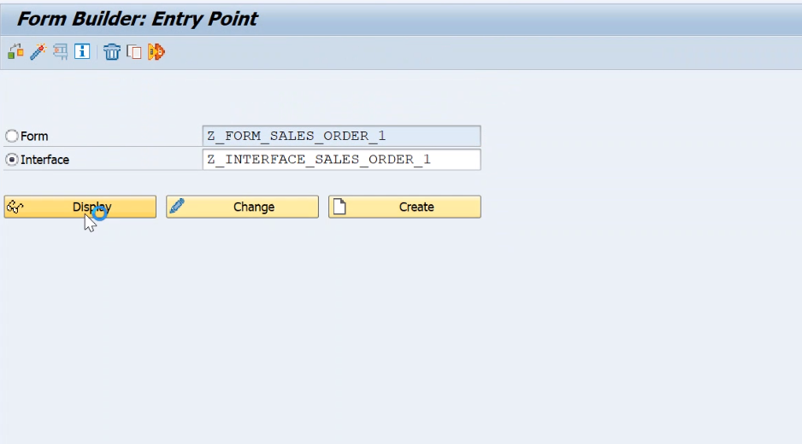

STEP 2: We are giving input parameter and declaring internal table for VBAK & VBAP fields.

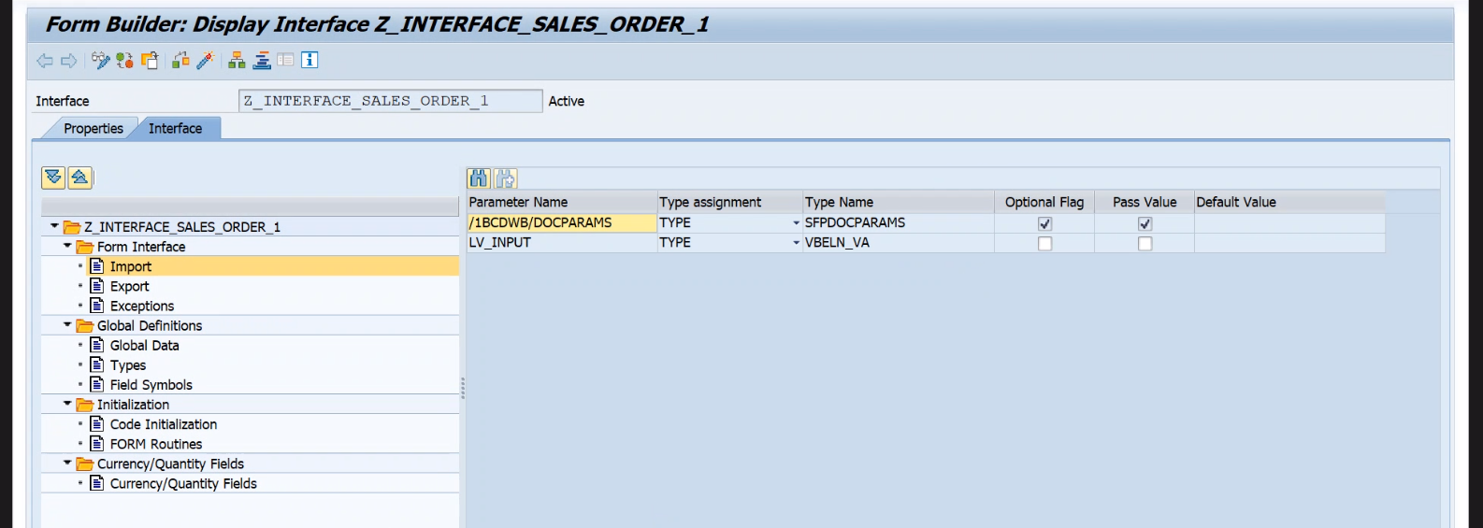

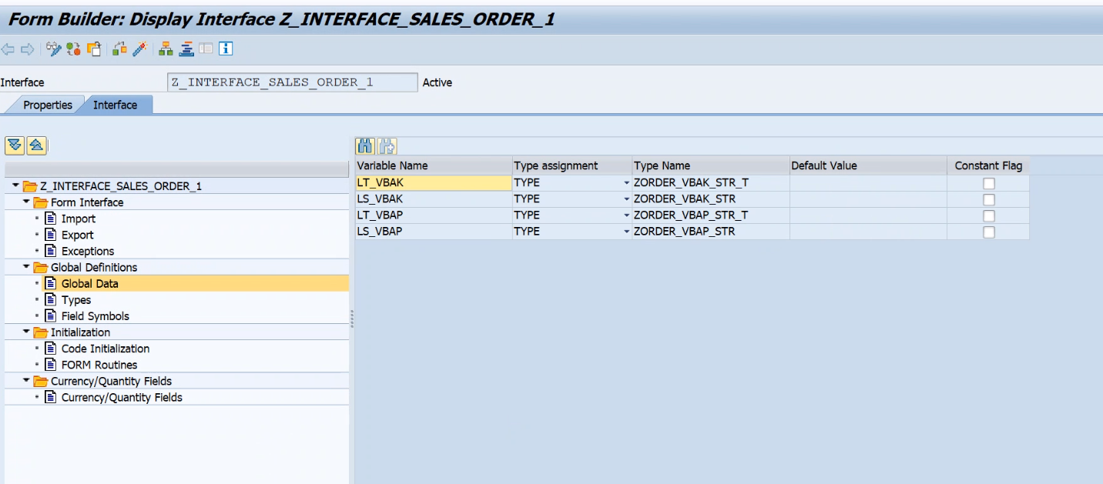

STEP 3: We will declare internal table and work areas in exporting parameter then we will write logic to fetch data from table in code initialize section.

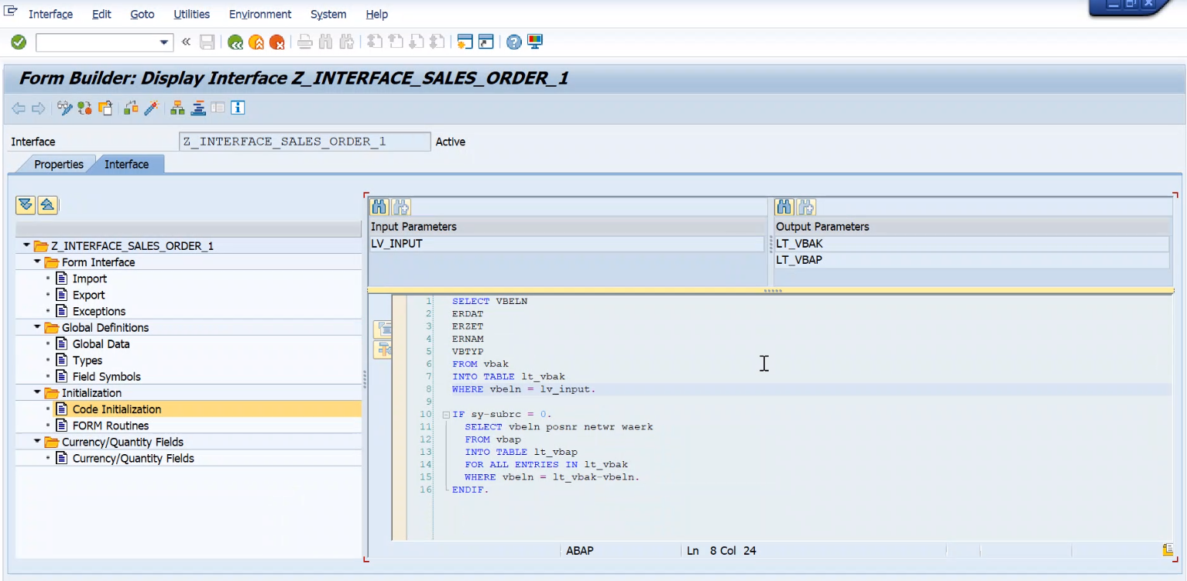

STEP4: We will create from as standard type by passing created interface, then we will drag and drop all the necessary importing/global data to context.

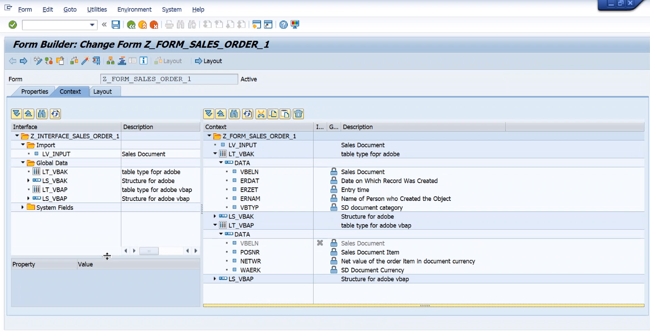

Step7: We will design layout of form as below, as per requirement.

Design by ADLC:

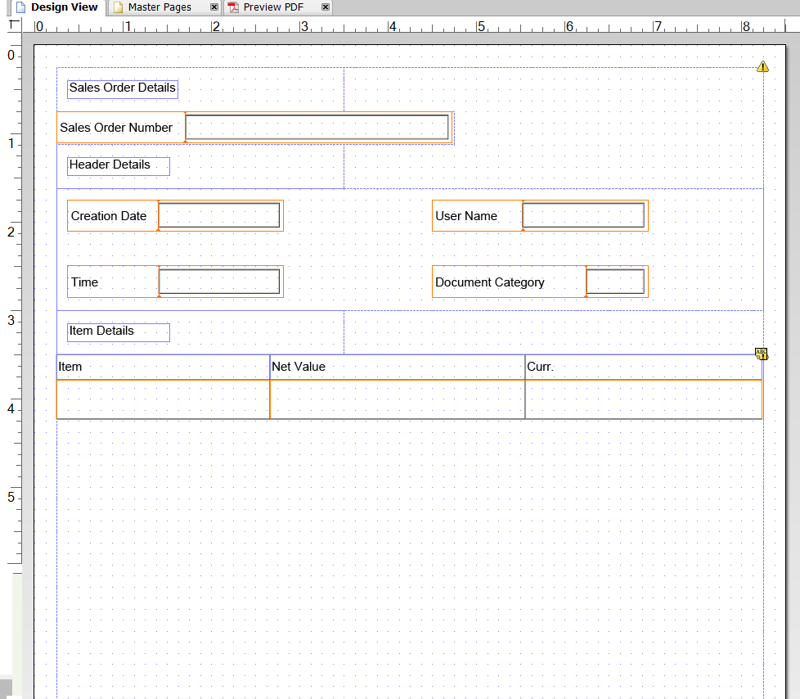

**OUTPUT:**

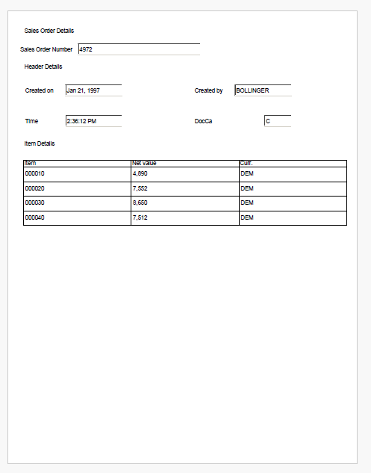

Note: We can use driver program explicitly to call the form, as below code.

REPORT ZNK_ADOBE_FORM.  
  
DATA: fm_name           TYPE rs38l_fnam,      " CHAR 30 0 Name of Function Module  
      fp_docparams      TYPE sfpdocparams,    " Structure  SFPDOCPARAMS Short Description  Form Parameters for Form Processing  
      fp_outputparams   TYPE sfpoutputparams, " Structure  SFPOUTPUTPARAMS Short Description  Form Processing Output Parameter  
      lv_input          TYPE vbeln_va.       " input data  
  
PARAMETERS : p_input like lv_input.  
* Sets the output parameters and opens the spool job  
CALL FUNCTION 'FP_JOB_OPEN'                   "& Form Processing: Call Form  
  CHANGING  
    ie_outputparams = fp_outputparams  
  EXCEPTIONS  
    cancel          = 1  
    usage_error     = 2  
    system_error    = 3  
    internal_error  = 4  
    OTHERS          = 5.  
IF sy-subrc <> 0.  
*            <error handling>  
ENDIF.  
*&---- Get the name of the generated function module  
CALL FUNCTION 'FP_FUNCTION_MODULE_NAME'           "& Form Processing Generation  
  EXPORTING  
    i_name     = 'Z_FORM_SALES_ORDER_1'  
  IMPORTING  
    e_funcname = fm_name.  
IF sy-subrc <> 0.  
*  <error handling>  
ENDIF.  
  
*&--- Call the generated function module  
call function fm_name "/1BCDWB/SM00006454'  
  exporting  
    lv_input                 = p_input  
          .  
if sy-subrc <> 0.  
* Implement suitable error handling here  
endif.  
  
*&---- Close the spool job  
CALL FUNCTION 'FP_JOB_CLOSE'  
*    IMPORTING  
*     E_RESULT             =  
  EXCEPTIONS  
    usage_error           = 1  
    system_error          = 2  
    internal_error        = 3  
    OTHERS               = 4.  
IF sy-subrc <> 0.  
*            <error handling>  
ENDIF.